Assignment 4 Analytical Processing

Total points: 50

This assignment should be completed individually. For each problem, submit your SQL statement and a screen shot of the SQL results in a single Word document or pdf file. Submit the file via eLearning.

I recommend creating a new user and workspace, log in as that user and load the database script DWDBINIT.sql (provided in this week's assignment folder).
Before you attempt to write any SQL queries, familiarize yourself with the database structure and data. I have provided a relational diagram and sample data for this database.
Write queries to address each of the problems below. Submit both the SQL statements and the screen prints of the outputs from Oracle.
SaleCo Snowflake schema

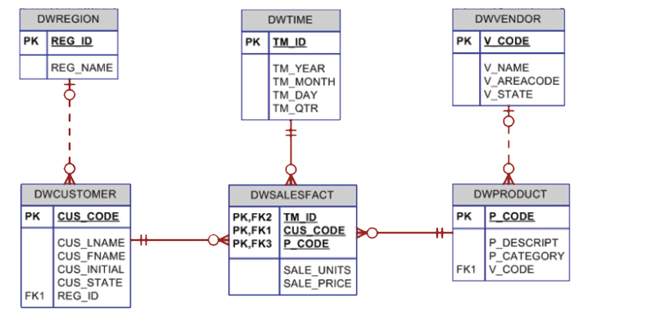

- Write a query that shows how each region performed in each quarter. Display the quarter, region name, and total sales for that region and quarter. Provide subtotals for each quarter and each region. Provide grand totals for each quarter and each region and a grand total for all. (HINT: You will need to first group the data by quarter and region and sum the sale_units*sale_price) Diplay the total sales in currency format ($999,999).
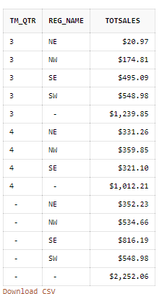

select tm_qtr, reg_name, to_char(sum(sale_units * sale_price), '$9,999.99') as "TOTSALES"
from dwregion dr, dwcustomer dc, dwsalesfact dsf, dwtime dt
where dr.reg_id = dc.reg_id
and dc.cus_code = dsf.cus_code
and dsf.tm_id = dt.tm_id
group by cube(tm_qtr, reg_name)
order by tm_qtr

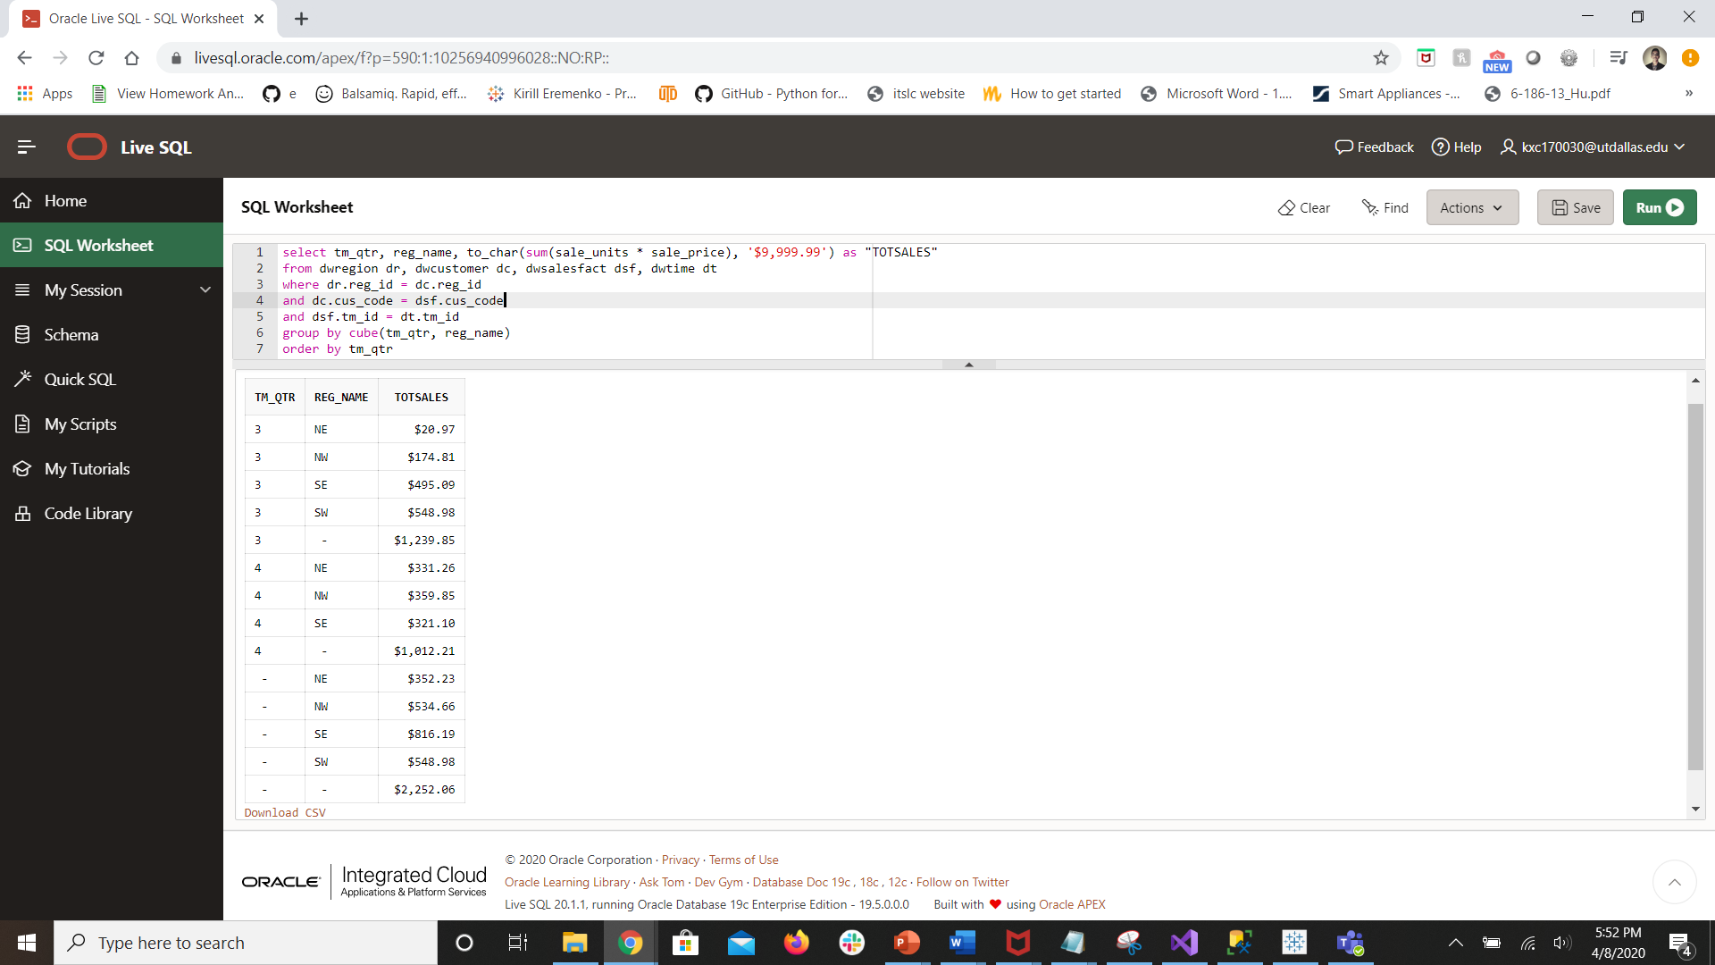

- Write a query to show the product sales by quarter and by region in a cross tabular format. Each quarter should be represented as a row, each region should be represented as a column. Order by quarter in ascending order.

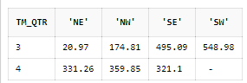

select *
from
(select tm_qtr, reg_name, sale_units, sale_price
from dwregion dr, dwcustomer dc, dwsalesfact dsf, dwtime dt
where dr.reg_id = dc.reg_id
and dc.cus_code = dsf.cus_code
and dsf.tm_id = dt.tm_id)
pivot
(sum(sale_units * sale_price)
for reg_name in ('NE', 'NW', 'SE', 'SW'))
order by tm_qtr asc

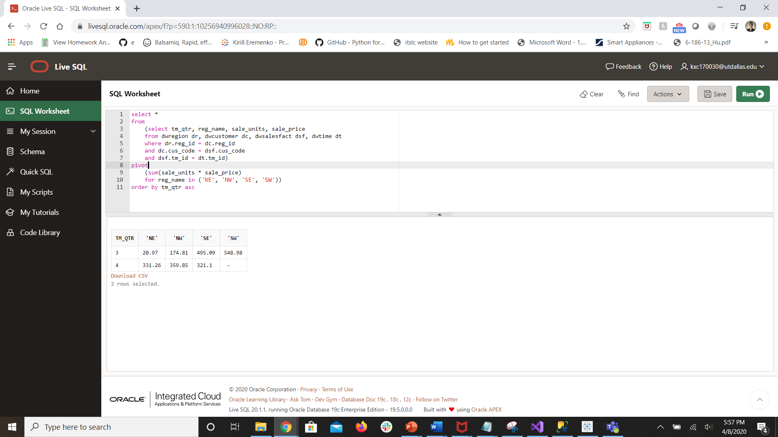

- Write a query that show how each product ranks in terms of sales in each region. You will display the region name, product code, total sold, and the rank. Lower ranks are assigned to those with more units sold.

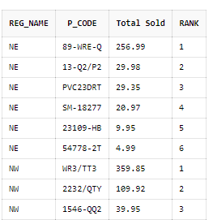

select reg_name, p_code, sum(sale_units * sale_price) as "Total Sold",
rank() over (partition by reg_name order by sum(sale_units * sale_price) desc) as "RANK"
from dwregion dr, dwcustomer dc, dwsalesfact dsf
where dr.reg_id = dc.reg_id
and dc.cus_code = dsf.cus_code
group by reg_name, p_code

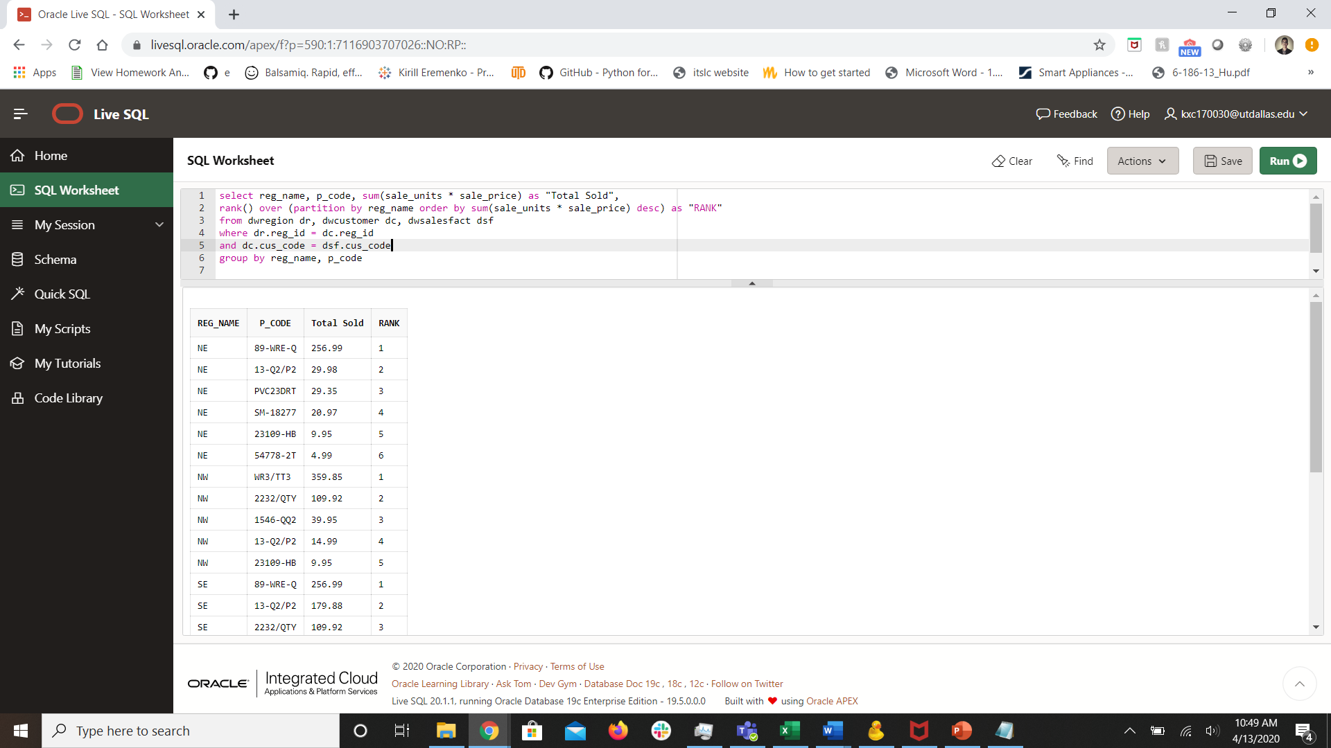

- Show how vendors rank in terms of number of units sold. Lower ranks are assigned to those with more units sold. Rank should not skip numbers.
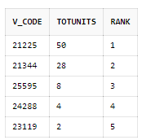

select v_code, sum(sale_units) as "TOTUNITS", dense_rank() over (order by sum(sale_units) desc) as "RANK"
from dwsalesfact dsf, dwproduct dp
where dsf.p_code = dp.p_code
group by v_code

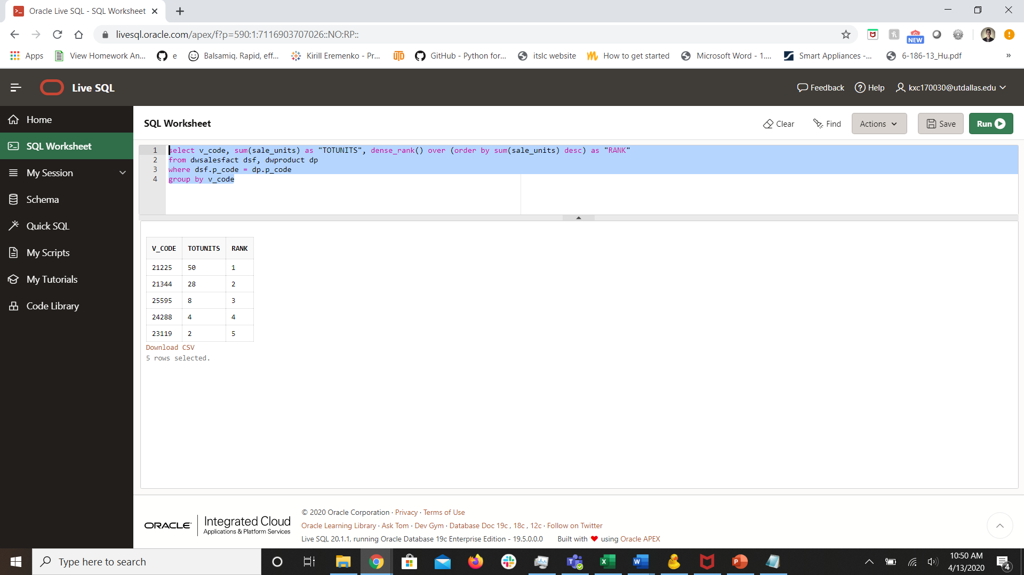

- Provide a rolling average for all sales in 09/2019. Display the total sales by day and the rolling (cumulative average). Display month and day in a single field as “9-29”.

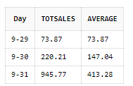

select tm_month ||'-'|| tm_day as "Day", sum(sale_units * sale_price) as "TOTSALES",
round(avg(sum(sale_units * sale_price)) over (order by tm_month, tm_day), 2) as "AVERAGE"
from dwtime dt, dwsalesfact dsf
where dt.tm_id = dsf.tm_id
and tm_month = 9
and tm_year = 2019
group by tm_month, tm_day

